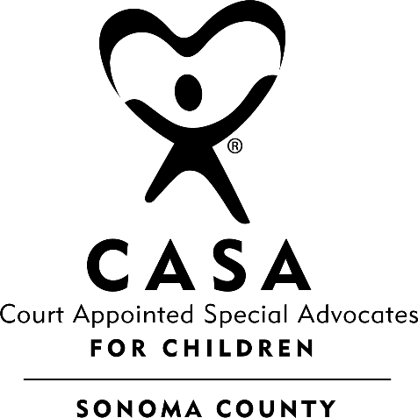

Court Appointed Special Advocates of Sonoma County, Inc.
P.O. Box 1418, Kenwood, CA 95452 (707) 565-6375/Fax: (707) 565-6379

COURT APPOINTED SPECIAL ADVOCATES
REPORT AND RECOMMENDATIONS
TO THE JUVENILE COURT OF SONOMA COUNTY

DATE OF HEARING: TYPE OF HEARING:

LOCATION: JUDGE / COMMISSIONER:
Department 5
CHILD/CASE No: AGE / DOB:

CASA ASSIGNED TO CASE: DATE ASSIGNED TO CASE:

To date, this CASA has spent a total of …….. hours on this case of which ………hours have been spent directly with …..youth

For Staff Use Only - Status Review: (Volunteer Supervisor Completes & Files)
Number of Continuing Education Hours since January:
Driver’s License Expiration Date: Driver’s Insurance Date:
Date of Fingerprints:
CASA in compliance:
Date of last Case Review: School updated in Optima:
FAMILY MEMBER S: AGE: CITY, STATE:

PERSONS CONTACTED: RELATION TO CHILD:

ASSESSMENT OF CHILD/CHILDREN’S WELL-BEING:

PLACEMENT:

(note the following:
Number of placements to date:
Any placement changes since last report:
Any Absence Without Leave (AWOL)? )

VISITATION WITH SIBLINGS / FAMILY:

EDUCATION:

INDEPENDENT LIVING PLAN (for youth 15 and over):
In this CASA’s opinion, the following points have been explained to the youth and the youth understands the following:
- Independent Living opportunities
- Acquiring Non-Minor Dependent status (AB12)
- The importance of storing personal documents in a secure location
- The importance of maintaining educational records
- The importance of maintaining health records and family medical history
- Financial needs to live independently
- Resources to assist with job search
- Career options (Job Corp, California Conservation Corps North Bay, Military Services, College, SRJC, Vocational training)

Together, this CASA and youth have:
- Toured VOICES
- Toured Santa Rosa Junior College Foster Care Services
- Participated in the CASA’s Successful Transitions Program

Please elaborate using the following questions as a guide:
Who is the ILP worker? Have transitional housing arrangements been made for minor when reaching non-minor dependent status (17+)? What is the minor’s opinion of his current preparation for independence? What are the minor’s interests and/or career choice? Is the minor employed? California Identification obtained and driving classes/license assessed if eligible)

HEALTHCARE – PHYSICAL, MENTAL/BEHAVIORAL HEALTH:
(note if child is prescribed psychotropic medications or any information from the JV223 on file)

RECOMMENDATIONS:
- Placement
- Education
- Healthcare – physical, mental/behavioral health and well-being
- CASA to remain on case to support these recommendations.

DATED:
RESPECTFULLY SUBMITTED:
________________________________________________
, Court Appointed Special Advocate

APPROVED BY:
________________________________________________
, Volunteer Supervisor

COPIES TO:
Dept 5: Social Worker, Attorney for Child, County Counsel, Attorney for Mother,
Attorney for Father
Dept 24: Probation, District Attorney, Public Defender

NAME: POSITION:
Social Worker
VIA Email:

Social Worker’s Supervisor
VIA Email:

Law Office of Madaliene Sowers Minor’s Attorney
VIA Email: juvdep4@gmail.com

Debra Bel, Attorney at Law Minor’s Attorney
VIA Email: dbel@pacbell.net

County Counsel
VIA Email:
1) Tricia.Porter@sonoma-county.org
2) jennifer.hernandez@sonoma-county.org

Dependency Legal Services Mother’s Attorney
VIA Email:
1)
2) dlssonoma@dependencyls.com

Dependency Legal Services Father’s Attorney
VIA Email:
1)
2) dlssonoma@dependencyls.com

David Fuller Father’s Attorney:
VIA Email: dfuller@sonic.net

Dependency Legal Services
- The DLS email is dlssonoma@dependencyls.com
- Julia Hanagan is @ hanaganj@dependencyls.com
- Matt Defer is deferm@dependencyls.com
- Jennifer Davis
- Ibrahim Agil is lawyer@abeagil.com

- Send every report to the DLS email AND to the assigned attorney

Dept 24
COPIES TO:
NAME: POSITION:

Probation
via email:Georgia.Polk@sonoma-county.org

Public Defender
via email: PUBDEF-JuvDiscovery@sonoma-county.org

District Attorney
via email: DA-Juv-Disc@sonoma-county.org>

